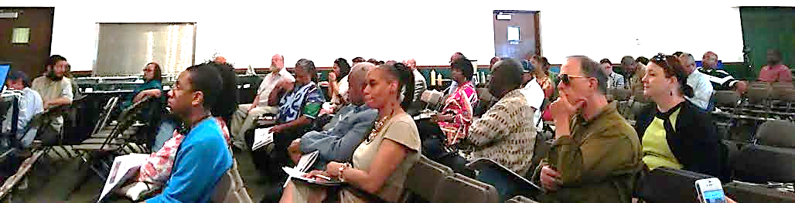

M-1 RAIL
Presents:
The M-1 RAIL
Community Update Meeting
Midtown Edition
Wednesday, July 9, 2014 – 5:30 p.m. to 8:00 p.m. The meeting will begin promptly at 6:00 p.m.
The MSU Detroit Center
3408 Woodward Avenue, Detroit, MI 48201

As M-1 RAIL moves forward with construction beginning Monday, July 27, this meeting will cover a number of topics specific to living and working during the construction of the rail:
Center
- Construction Schedule
- Maintenance of Traffic
- Resident Communications

Please join us to learn all of the latest details on the project and have your questions answered. Street parking is available and in the MSU Detroit Center Parking Lot located on the corner of Woodward and Erskine. Please RSVP by Tuesday, July 8 to Nicole Brown, M-1 RAIL Community Relations Manager at nicole.brown@m1rail.org or 313.483.8077.

