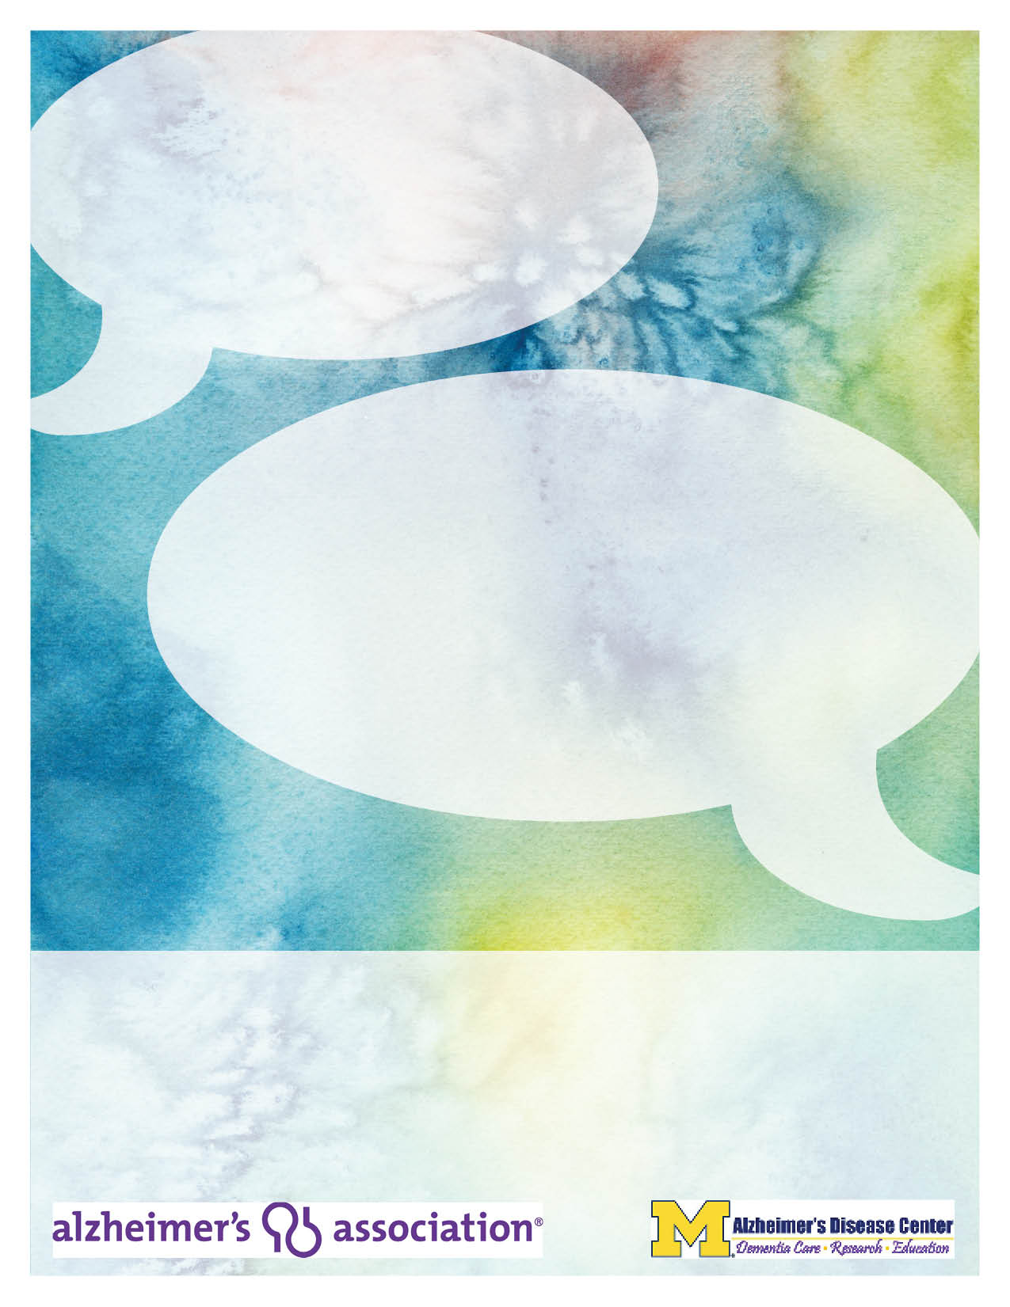
Register Today!
The program is free for individuals with memory loss and family caregivers. The program is $35 for professionals.
To register, call (248) 996-1053 or trusso@alz.org or register online at www.alz.org/gmc
Registration is requested by June 6, 2013.
Parking for the conference is available in the North Lot.
Free respite services available in Southfield or Detroit. Advanced registration required.

Continuing Education Units
This program has been approved by the Michigan Social Work Continuing Education Collaborative for three (3) Continuing Education credits. St. Mary Mercy Hospital is accredited as a provider for continuing nursing education by the American Nurses Credentialing Center’s Commission on Accreditation. This program has been approved for three (3) Continuing Education credits.
Certificate of Attendance offered for activity professionals, occupational therapists, physical therapists, and speech therapists.

Thursday, June 13, 2013
8:00 a.m. – 12:00 p.m.

St. Mary Mercy Hospital
36475 Five Mile Road, Livonia, MI 48154

Please join us to learn more about the use of creativity in strengthening meaningful interactions
“Sharing Our Lives, Creating Our Stories”
Beth Spencer, MA, LMSW

“SEEING – MAKING – MEANING: In the Galleries and in the Studio
at the Detroit Institute of Arts”
Eric Gill, LaVern Homan & Christine Mark-Curtis

Connecting, Coping, and Caring through Creativity
A Conference for Individuals with Memory Loss, Caregivers, and Healthcare Professionals

