Senior Apartments Served by Hannan Foundation Service
Coordinators: Presbyterian Villages of Michigan

Village of Bethany Manor
8737 14th Street, Detroit, MI, 48206
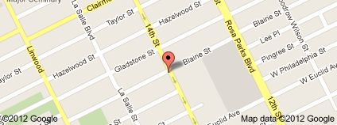Service Coordinator: Patricia Gray, 313-894-0430, 9 – 4:30 Tues., & Thurs.

Village of Brush Park Manor
2900 Brush, Detroit, MI, 48201
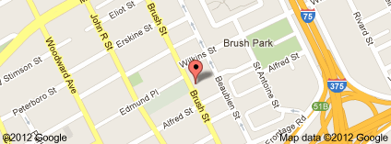Service Coordinator: Harold Massingille, 313-832-1576, 9 – 5 Mon., - Fri.

Village of Harmony Manor
15050 Birwood, Detroit, MI, 48238
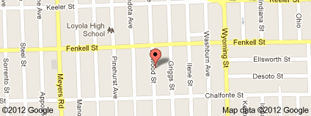Service Coordinator: Trudy Jones, 313-934-4000 ext. 3, 9 -5, Tues., & Thurs.

Village of Oakman Manor
1400 Woodrow Wilson, Detroit, MI, 48238
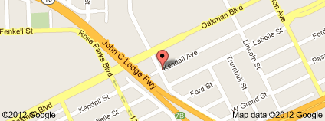Service Coordinator: Wylene Jones, 313-957-0423, 9 – 5, Mon., & Thurs.

Village of Woodbridge Manor
1300 Martin Luther King Blvd., Detroit, MI, 48201
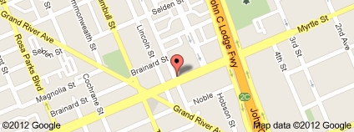Service Coordinator: Annette Pledger, 313-494-9000 ext. 4, 9 – 5, Mon., - Fri.
Senior Apartments Served by Hannan Service Coordinators: CSI Support and Development Services

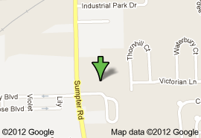Belleville Cooperative Apartments
575 Sumpter Rd., Belleville, MI, 48111
Service Coordinator:
Matt Hamburg, 734-699-3833
9 – 5, Tues., & Thurs.

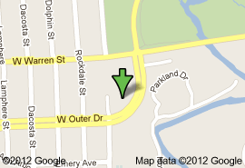Dearborn Heights Cooperative Apartments
16600 Outer Drive,
Dearborn Heights, MI, 48217
Service Coordinators:
Andrea Krueger, 313-563-3180
8 – 4, Mon., - Fri.
Adrienne Smith, 313-563-3160
9 – 5, Mon., - Fri.

Flat Rock Towers Cooperative Apartments
28744 Telegraph Rd., Flat Rock, MI, 48134
Service Coordinator:
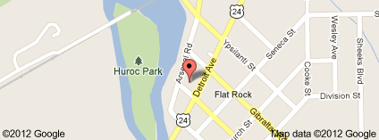Renee Saunders, 734-783-4820, 9 – 5 Mon., - Fri.

Hazel Park Manor Cooperative Apartments
701 East Woodward Heights Blvd., Hazel Park, MI, 48030
Service Coordinator:
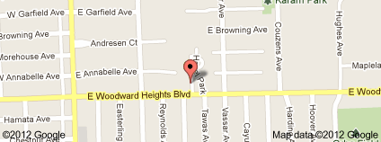Alexa Lempert, 248-399-1810, 9 – 5 Mon., - Fri.

LaBelle Towers Cooperative Apartments
33 LaBelle Street
Highland Park, MI, 48203
Service Coordinators:
Diane Crawford, 313-883-8140, 9 – 5, Mon., - Fri.
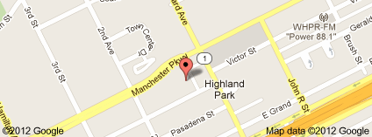

Madison Heights Cooperative Apartments
500 East Irving Ave., #A Madison Heights, MI, 48071
Service Coordinators:
Ting Chang, 248-585-2080
Harriet Harris, 248-585-2080
Katherine Simpson, 248-585-2084
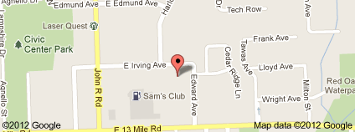Kari Wilson, 248-585-2084, 9 – 2, Mon., Tue., Thurs., Fri.

Meyers Plaza Cooperative Apartments
18000 Meyers Rd., Detroit, MI, 48235
Service Coordinator:
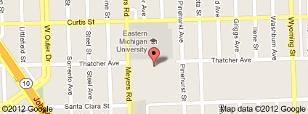Jane Grant, 313-862-1954

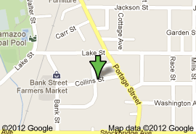Washington Square Cooperative Apartments
710 Collins St., Kalamazoo, MI, 49001
Service Coordinators:
Karen Baker, 269-343-8870
Lara Wahl, 269-343-8860
8:30 – 4:30, Mon., - Fri.

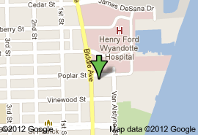Wyandotte Cooperative Apartments

2455 Biddle Ave., Wyandotte, MI, 48192
Service Coordinators:
Lindsay Kohler, 734-282-5448
Maryannette Grayer, 734-282-5440
9 – 5, Mon., - Fri.

